**ASSIGNMENT-1**

Name: Mamidi Pavan Kiran

Trainer Name: Harshee Pithroda

Course Name: Python and Machine Learning Basic Course

Date: 24-05-2022

**Question:1**

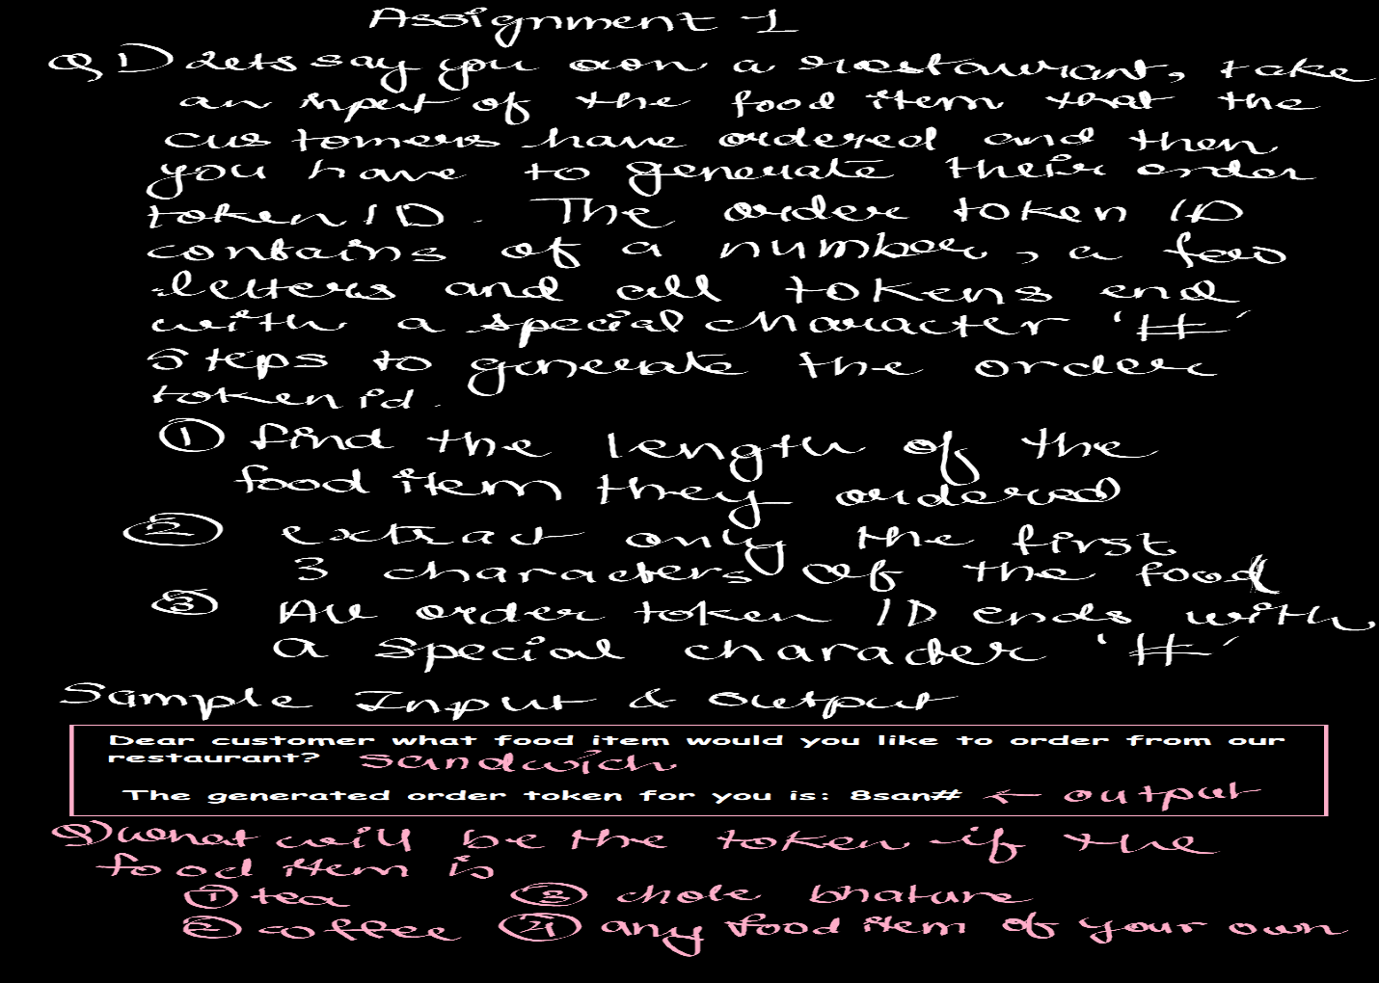

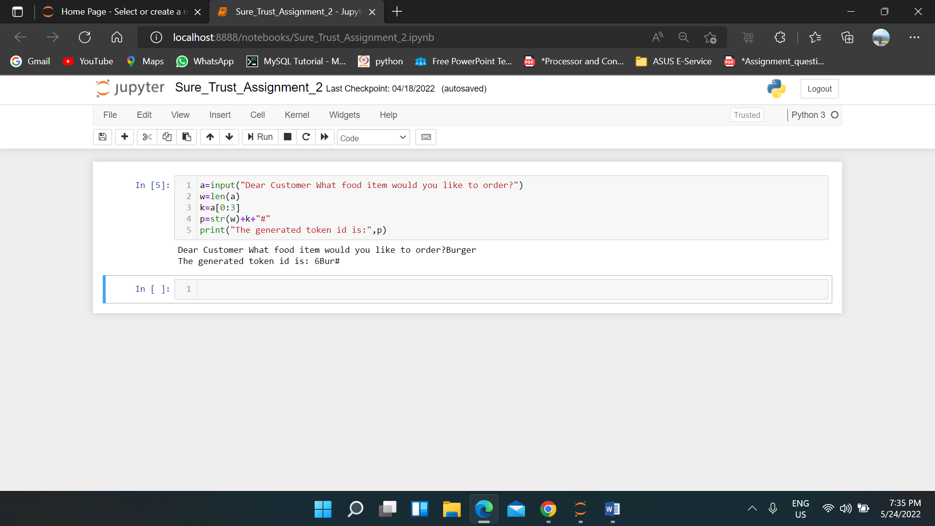

Question-2

